Project Title
AUTOMATED STUDENT LAB ALLOCATION USING MAXIMUM BIPARTITE MATCHING
Project Report submitted for the partial fulfilment of grade for the course

Data Structures and Algorithms -3 (25CS2103E)
in

A.Y. 2026-2027

Submitted by
N. Greeshma – 2520030080
M. Keerthi Sri – 2520030079
K. Swathi Sree - 2520030410

Team Number: 7
Section: 7

Under the guidance of

Dr. S. Madhavi

Assistant Professor, CSE
Hyderabad-500090, Telangana, India.

K L (Deemed to be) University
DEPARTMENT OF COMPUTER SCIENCE ENGINEERING



DECLARATION

The Mini Project Report entitled “Automated Student Lab Allocation Using Maximum Bipartite Matching” is a record of Bonafide work of N. Greeshma – 2520030080, M. Keerthi Sri – 2520030079, K. Swathi Sree - 2520030410. submitted in partial fulfillment for the award of B. Tech in Computer Science and Engineering to the K L University. The results embodied in this report have not been copied from any other departments/University/Institute.

N. Greeshma – 2520030080,
M. Keerthi Sri – 2520030079,
K. Swathi Sree – 25200300410.

K L (Deemed to be) University
DEPARTMENT OF COMPUTER SCIENCE ENGINEERING
CERTIFICATE

This is to certify that the mini project-based report entitled “Automated Student Lab Allocation Using Maximum Bipartite Matching” is a Bonafide work done and submitted by N. Greeshma – 2520030080, M. Keerthi Sri – 2520030079, K. Swathi Sree - 2520030410. in partial fulfillment of the requirements for the award of the degree of BACHELOR OF TECHNOLOGY in Department of Computer Science Engineering, K L (Deemed to be University), during the academic year 2026-2027.

Signature of the Supervisor

Signature of the HOD Signature of the External Examiner

ACKNOWLEDGEMENT

The success in this project would not have been possible but for the timely help and guidance rendered by many people. Our wish to express my sincere thanks to all those who has assisted us in one way or the other for the completion of my project.

Our greatest appreciation to my guide, Dr. S. Madhavi, Assistant Professor, CSE which cannot be expressed in words for his/her tremendous support, encouragement and guidance for this project.

We express our gratitude to Dr. P. Venkateshwar Rao (CSE) Head of the Department for Computer Science Engineering for providing us with adequate facilities, ways and means by which we are able to complete this project-based Lab.

We thank all the members of teaching and non-teaching staff members, and also who have assisted me directly or indirectly for successful completion of this project. Finally, I sincerely thank my parents, friends and classmates for their kind help and cooperation during my work.

N. Greeshma – 2520030080,
M. Keerthi Sri – 2520030079,
K. Swathi Sree – 25200300410.

TABLE OF CONTENTS

S.No. | Contents | Page no.
1. | Abstract | 6
2. | Introduction | 7
3. | Literature survey | 8
4. | Problem Statement and Objectives | 10
5. | Hardware and Software requirements | 11
6. | Implementation | 12
7. | Results & Discussion | 16
8. | Conclusion & Future Scope | 18
9. | References | 19

1.ABSTRACT

The Automated Student Lab Allocation System is a Java-based application developed to automate the process of assigning students to available laboratory seats. Manual laboratory allocation becomes time-consuming and error-prone when the number of students and available laboratories increases. To address this problem, the proposed system models the allocation process as a bipartite graph, where students form one set of vertices and individual laboratory seats form the other set. The Hopcroft–Karp maximum bipartite matching algorithm is implemented to efficiently generate a maximum matching between students and available seats.
The system accepts student and laboratory information through Excel and text files. Apache POI is used for processing Excel data, while Java-based services handle data conversion and processing. After obtaining the maximum matching, a seating optimization component organizes the allocated students into physical laboratory positions such as rows, columns, and seat numbers. Additional algorithmic components, including KMP string matching and Bitmask Dynamic Programming, are incorporated to demonstrate relevant Data Structures and Algorithms concepts. A web-based frontend communicates with the Java backend and displays the generated allocation in an organized manner.
The system reduces manual effort, minimizes allocation errors, improves utilization of available laboratory seats, and demonstrates the practical application of graph algorithms to a real-world resource allocation problem.
Team Members:
- N. Greeshma – 2520030080
- M. Keerthi Sri – 2520030079
- K. Swathi Sree - 2520030410

- INTRODUCTION

The Lab Allocation System is a software-based solution designed to simplify and automate the process of assigning students to laboratory rooms. In educational institutions, allocating a large number of students to different laboratories manually can be time-consuming and may lead to uneven distribution, capacity violations, and difficulties in managing student records.
The proposed project addresses these challenges by providing a systematic method for laboratory allocation. The system accepts a student dataset containing details such as Roll Number, Name, and Branch, along with a laboratory dataset containing information such as Lab Name, Number of Rows, Number of Columns, and Capacity. Based on the available laboratory capacity, the system automatically assigns students to suitable laboratories while ensuring that the number of students assigned does not exceed the available capacity.
The main objective of the project is to make the laboratory allocation process faster, organized, accurate, and easy to manage. It reduces manual effort and provides a clear allocation of students to laboratories. The system can also be useful when dealing with multiple branches and a large number of students, where manual allocation becomes difficult and error-prone.
The project focuses on developing a simple and user-friendly system that can process uploaded datasets and generate an organized laboratory allocation. The resulting allocation can be viewed and used by faculty members or administrators for laboratory sessions, examinations, practical classes, and other academic activities.
The remainder of this document describes the problem statement, objectives, existing and proposed systems, system requirements, methodology, system design, implementation, results, and future enhancements of the proposed Lab Allocation System.

- LITERATURE SURVEY

3.1 University Timetabling and Scheduling Systems
University timetabling systems are designed to allocate students, faculty, classrooms, and laboratory resources according to predefined constraints. These systems help institutions reduce scheduling conflicts and make efficient use of available resources. Many solutions use constraint-based approaches to handle room capacity, student groups, subjects, and available time slots. The study of such systems provides a foundation for developing an automated laboratory allocation system that can distribute students efficiently among available laboratories.

3.2 Automated Classroom Allocation Systems
Automated classroom allocation systems focus on assigning classes or student groups to available rooms based on room capacity and other constraints. These systems reduce the effort required for manual allocation and help prevent situations where the number of students exceeds the available seating capacity. Room allocation approaches can be extended to laboratory allocation by considering the capacity and physical arrangement of each laboratory. Such systems are useful for designing an efficient resource allocation mechanism.

3.3 Examination Seating Arrangement Systems
Examination seating arrangement systems automatically assign students to examination rooms according to available seats and institutional rules. These systems generally use student information and room capacity as input and generate an organized seating arrangement. They help minimize manual work and reduce errors during large-scale examinations. The concepts used in examination seating allocation are closely related to the proposed project because both systems require students to be distributed among available rooms without exceeding capacity.

3.4 Course and Laboratory Scheduling Systems
Course scheduling systems manage the allocation of courses to classrooms and laboratories while considering room availability and capacity. Such systems are particularly useful in educational institutions where multiple departments share limited laboratory resources. Scheduling algorithms can improve resource utilization and avoid conflicts between different student groups. These approaches provide useful ideas for developing a system that assigns students to different laboratories based on their available capacity.

3.5 Constraint-Based Scheduling
Constraint-based scheduling is widely used for solving complex allocation problems. In educational scheduling, constraints may include room capacity, availability, student groups, faculty requirements, and resource limitations. The system searches for an allocation that satisfies the required constraints while making efficient use of available resources. This approach is relevant to the proposed Lab Allocation System because student allocation must respect the capacity constraints of each laboratory.

3.6 Genetic Algorithm-Based Timetabling
Genetic algorithms have been applied to university timetabling and resource allocation problems. These algorithms generate possible solutions and iteratively improve them according to a fitness function. They are useful when the number of students, rooms, subjects, and constraints becomes large. Although the proposed project can use a simpler allocation strategy, studying genetic algorithm-based scheduling helps understand how optimization techniques can be applied to improve resource utilization and allocation quality.

3.7 Student Allocation and Resource Management Systems
Student allocation systems are developed to distribute students among available classes, sections, rooms, or other academic resources. These systems generally process student records and use predefined rules to generate allocations. Automated allocation reduces repetitive administrative work and makes the allocation process more consistent. The proposed project follows a similar concept by taking a student dataset and a laboratory dataset and generating an organized laboratory assignment.

3.8 Resource Scheduling and Optimization Platforms
Modern resource scheduling platforms provide automated methods for assigning limited resources to multiple users or groups. They commonly consider resource availability, capacity, and user requirements before generating an allocation. These concepts can be applied to academic laboratory management, where laboratories are limited resources and students need to be distributed efficiently. The proposed project adapts these resource-allocation principles specifically for student laboratory allocation.

- Problem Statement and Objectives

Problem Statement
Manual allocation of students to multiple laboratories is time-consuming and can result in capacity violations, uneven distribution, and allocation errors.

Problem Description
When many students have to be assigned to laboratories with different capacities, manual allocation becomes difficult to manage accurately. A computerized system is required to automatically process student and lab datasets and generate a valid allocation.

Objectives:
- To automate the allocation of students to available laboratories.
- To reduce the time and manual effort required for lab allocation.
- To ensure that laboratory capacity is not exceeded.
- To process student details through a structured CSV dataset.
- To process laboratory details such as rows, columns, and capacity.
- To generate an organized student-to-laboratory allocation.
- To reduce human errors during the allocation process.
- To provide a simple and user-friendly lab allocation system.
- To support multiple laboratories with different seating capacities.
- To generate an allocation that can be easily viewed and managed.

- HARDWARE AND SOFTWARE REQUIREMENTS

Hardware Requirements:
- Processor: Intel Core i3 or above
- RAM: Minimum 4 GB
- Storage: Minimum 500 MB free space
Software Requirements:
- Operating System: Windows / Linux
- Frontend: HTML, CSS, JavaScript
- Backend: Node.js and Express.js
- Development Environment: Visual Studio Code
- Dataset Format: CSV
- Web Browser: Google Chrome / Microsoft Edge

- IMPLEMENTATION

Module-1: KMP
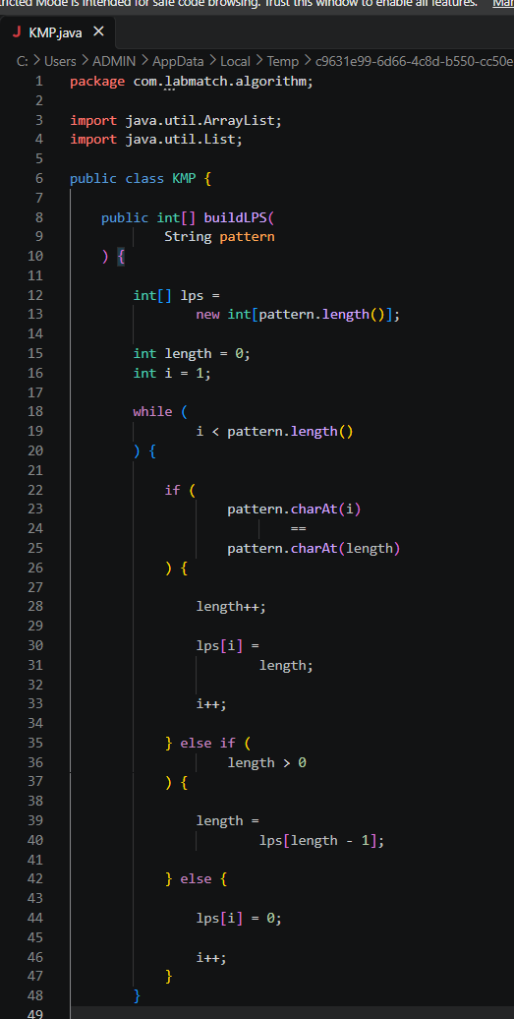

Module – 2 : HopCroftKarp
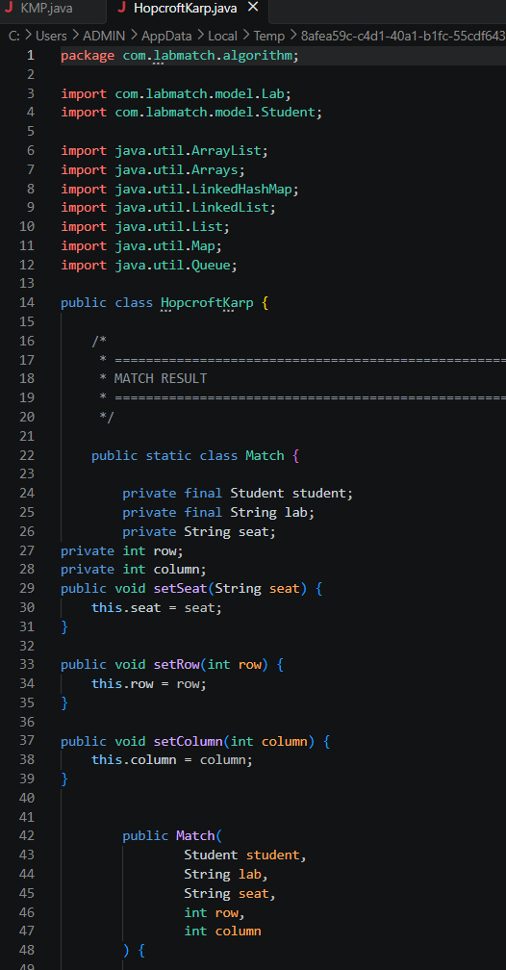

Module – 3 : Bitmask DP
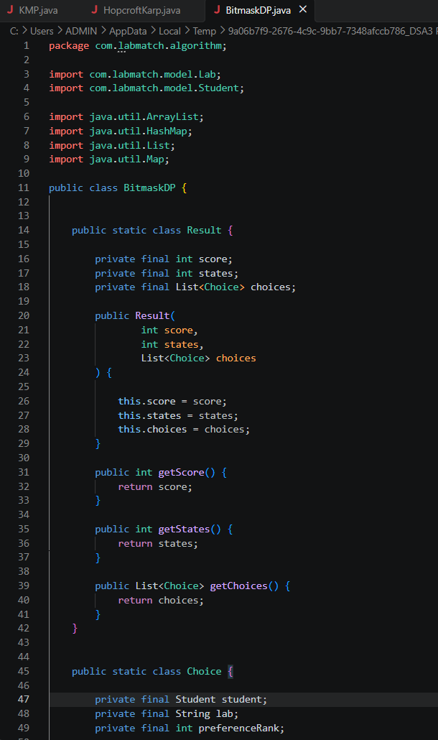
Module – 4 : Seating Optimizer
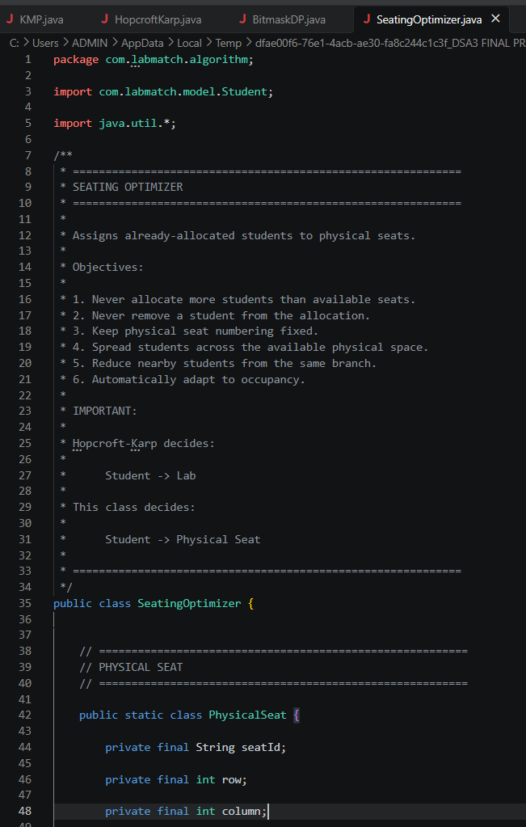
- RESULTS & DISCUSSION
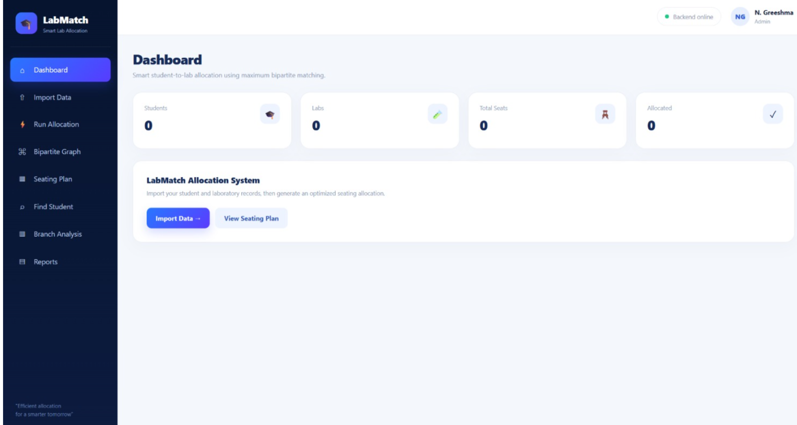
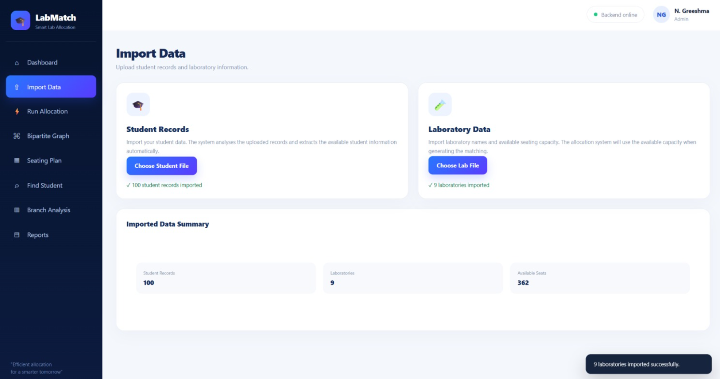
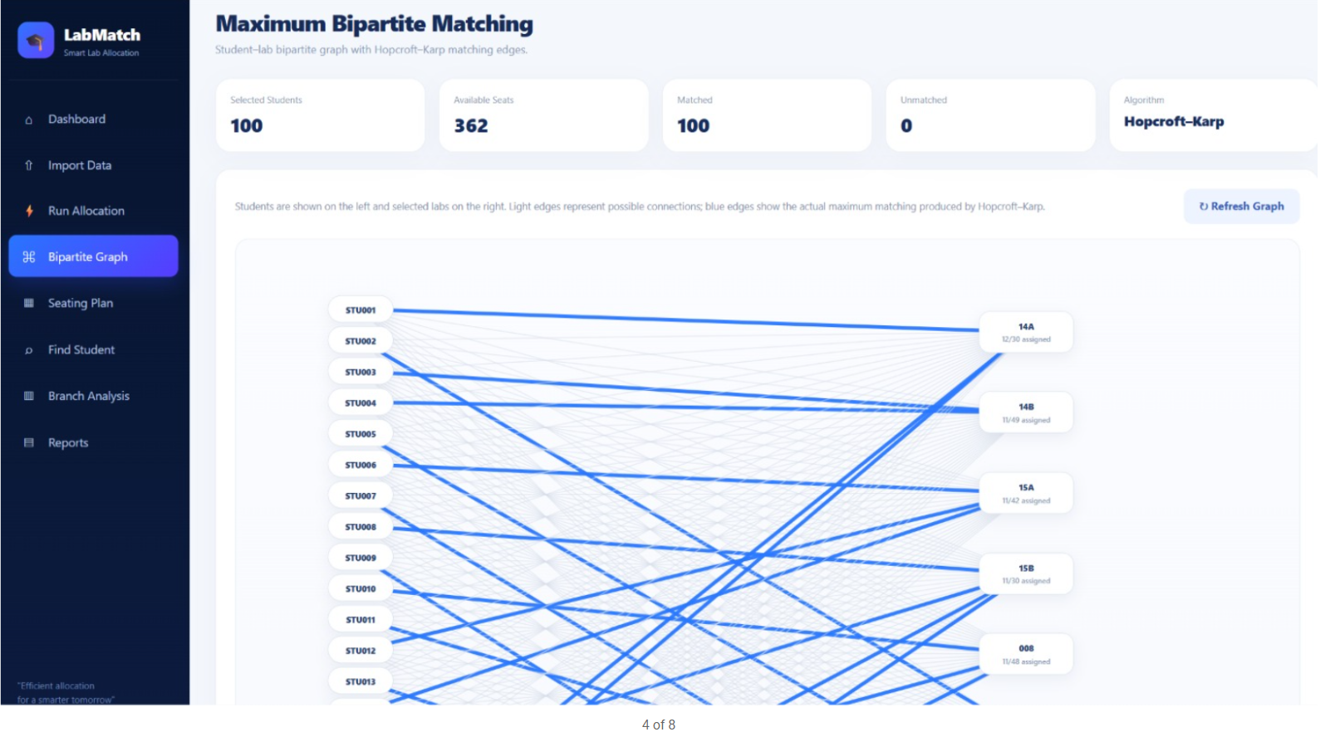

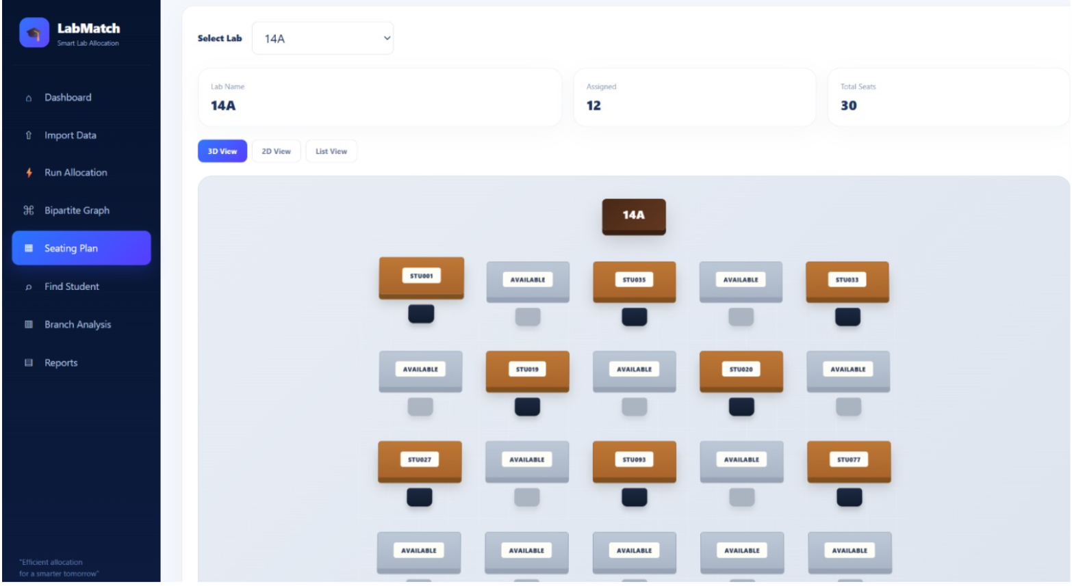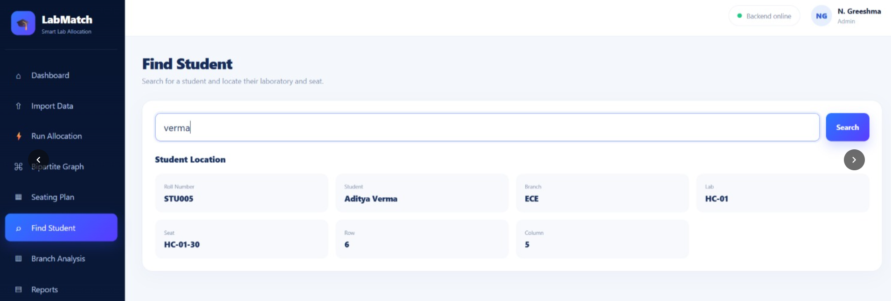

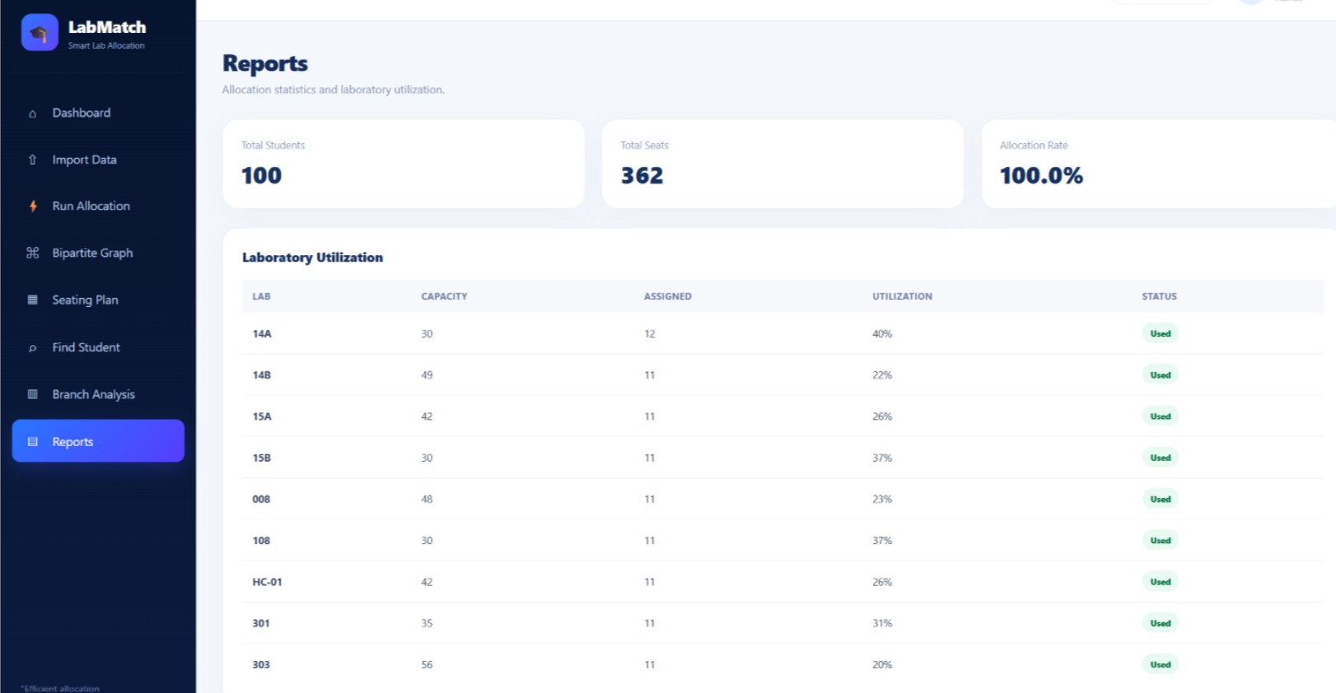

- CONCLUSION & FUTURE SCOPE
Conclusion
The Student–Lab Allocation System successfully addresses the problem of manually assigning students to multiple laboratories. The system processes student and laboratory datasets and automatically allocates students based on the available laboratory capacity. The project reduces manual effort, minimizes allocation errors, and provides an organized and user-friendly allocation process. The major objectives of automating the allocation, handling multiple laboratories, and ensuring that laboratory capacity is not exceeded were successfully achieved.
Future Scope
The future development of the project can be carried out in different stages:
Near-Term Enhancements:
- Add Excel and PDF export for the generated allocation.
- Improve the user interface and provide better allocation summaries.
- Add validation for duplicate or invalid student records.
Medium-Term Enhancements:
- Implement individual seat allocation using row and column positions.
- Add branch-wise and balanced student allocation.
- Add database integration for storing student and laboratory records.
- Provide an administrator dashboard for monitoring laboratory capacity.
Long-Term Enhancements:
- Implement optimization algorithms for large-scale student allocation.
- Support real-time laboratory availability and allocation updates.
- Integrate the system with existing college academic management systems.
- Develop advanced analytics to improve laboratory resource utilization.

- REFERENCES

- UniTime – University Timetabling System
https://www.unitime.org/
- UniTime – Student Scheduling
https://help-unitime.unitime.org/uct_students.php
- UniTime – Examination Timetabling
https://help40.unitime.org/examination-timetabling
- UniTime – Room Details and Capacity
https://help45.unitime.org/room-detail
- OptaPlanner – School Timetabling
https://docs.optaplanner.org/latest/optaplanner-docs/html_single/
- OptaPlanner – Examination Timetabling
https://docs.optaplanner.org/6.4.0.Final/optaplanner-docs/html/ch03.html
- FET – Free Timetabling Software
https://lalescu.ro/liviu/fet/
- Springer – University Course Timetabling Research
https://link.springer.com/article/10.1007/s10951-021-00715-5
- Springer – Curriculum-Based University Course Timetabling
https://link.springer.com/article/10.1007/s10100-024-00923-2
- UniTime Documentation
https://help.unitime.org/

